**Kubernetes health probes** are used to monitor the health and readiness of applications running inside containers. These probes allow Kubernetes to determine whether an application is functioning correctly and ready to handle traffic.

There are three types of Kubernetes health probes:

**1. Liveness Probe**

* **Purpose**: Checks whether the application is alive and running. If the liveness probe fails, Kubernetes will kill the container and, based on the restart policy, restart it.
* **Common Use Case**: Detect when an application has become deadlocked or is in an unrecoverable state.

**2. Readiness Probe**

* **Purpose**: Determines if the application is ready to serve traffic. Now let’s say there is an application which take 30sec to bootup and start completely till that user will get “ERROR” can’t access the application. To avoid this readiness makes sure that your application only expose to user only when it fully added to loadbalancer once the readiness probe are passed. If the readiness probe fails, Kubernetes will remove the Pod from the list of endpoints for the Service until it passes.
* **Common Use Case**: Delay traffic to the application until it's fully initialized and ready to accept requests.

**3. Startup Probe**

* **Purpose**: Ensures that the application has started successfully. If the startup probe fails, Kubernetes will restart the container. Once the startup probe passes, Kubernetes stops performing liveness or readiness checks.
* **Common Use Case**: Useful for applications with slow startup times, to prevent them from being prematurely killed or marked as unready by the liveness or readiness probes.

**LIVNESS PROBE case:** The container starts and immediately creates the file /tmp/healthy. After 5 seconds (as per initialDelaySeconds), Kubernetes runs the cat /tmp/healthy command to check if the file exists. The probe will succeed while the file exists.After 30 seconds, the file /tmp/healthy is deletedOnce the file is deleted, the next liveness probe (which runs every 5 seconds) will fail because the cat /tmp/healthy command will return an error. Once the probe fails, Kubernetes will consider the container unhealthy and will restart it.

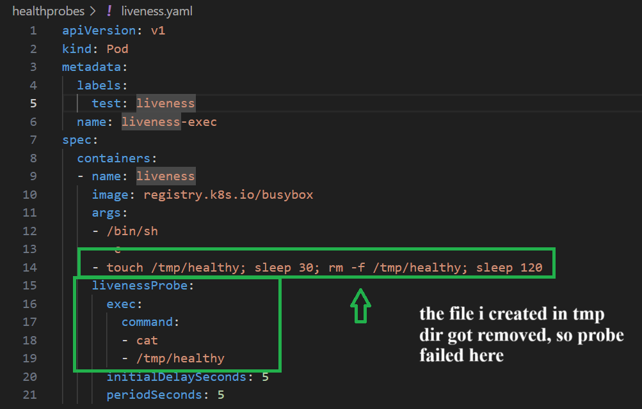

Pod is getting restarted again and again

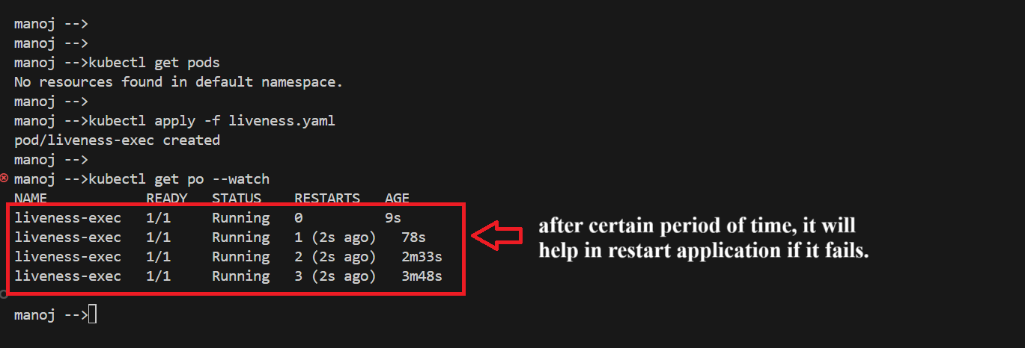

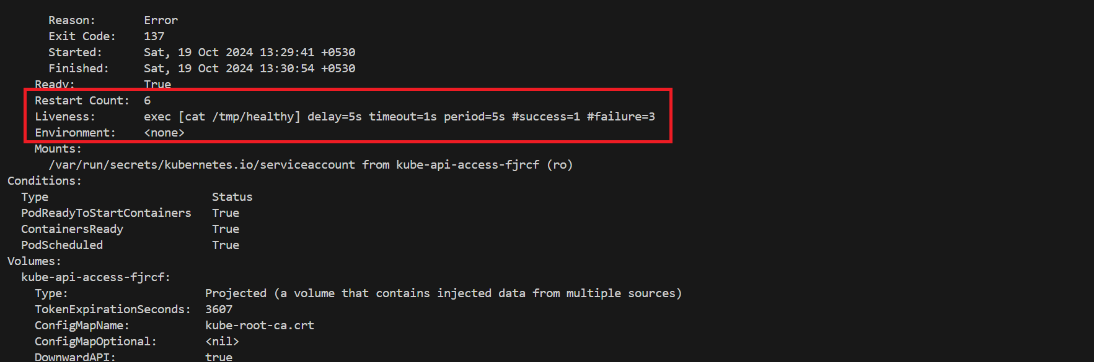

We can see that liveness probe failed because “tmp/healthy” directory can’t be found.

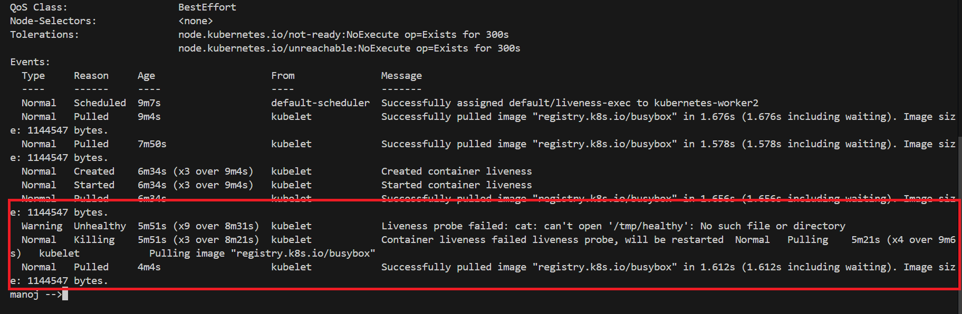

**LIVENESS PROBE AND READINESS PROBE case:** In this I didn’t exposed the container port

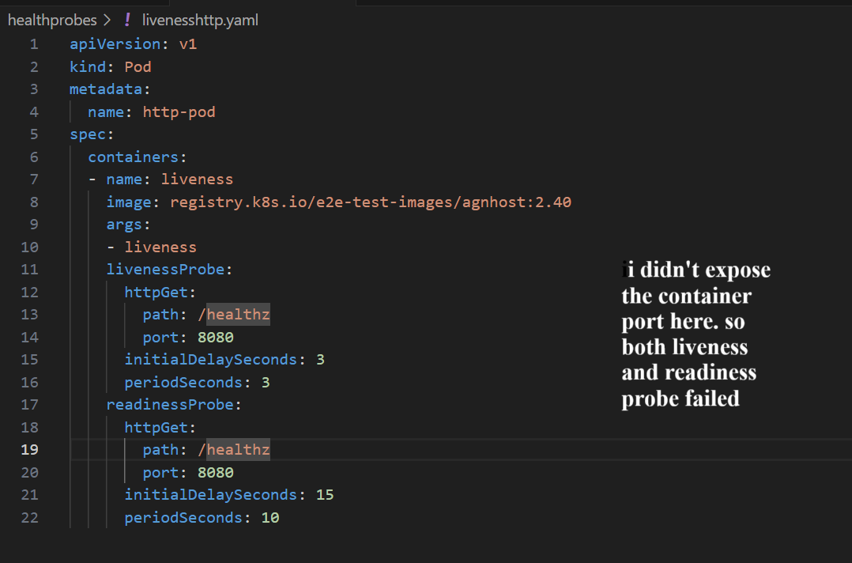

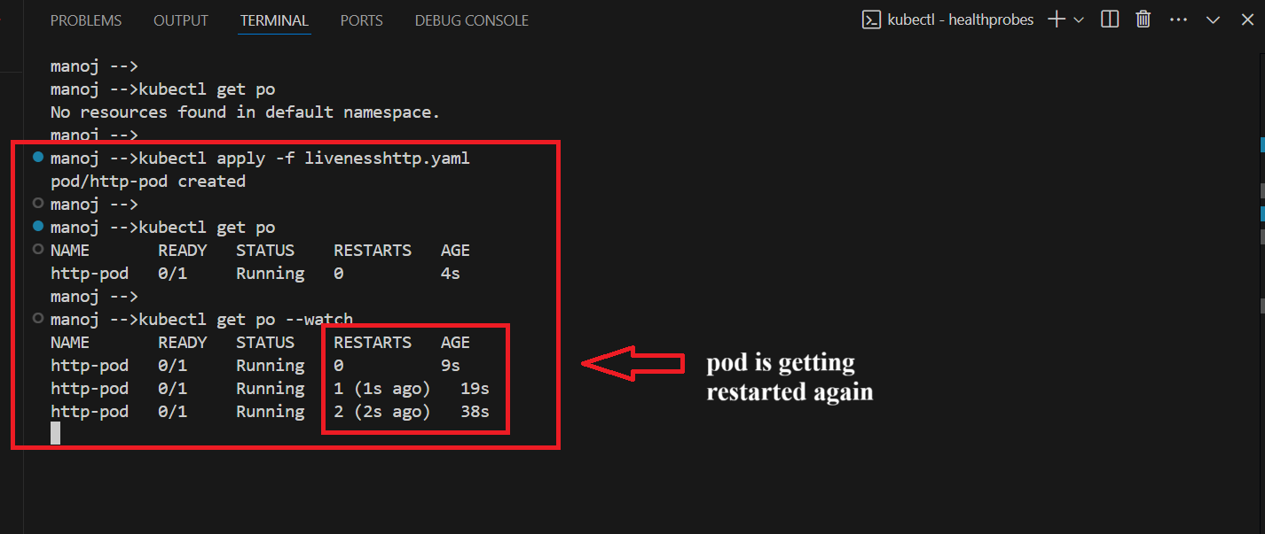

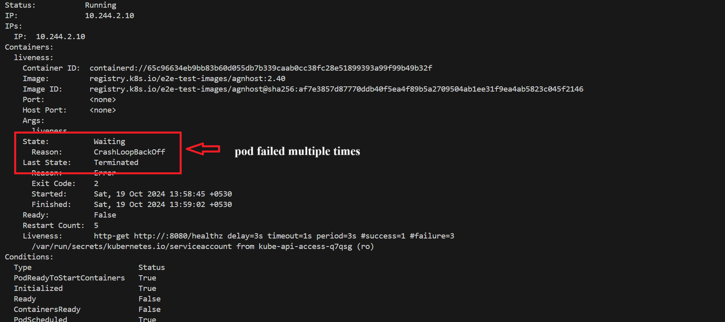

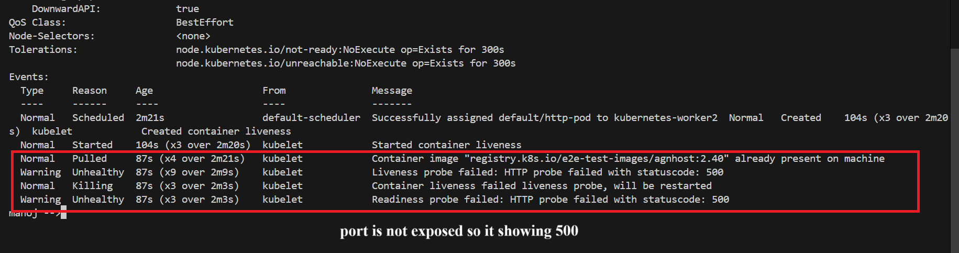

**Now I exposed the port:**

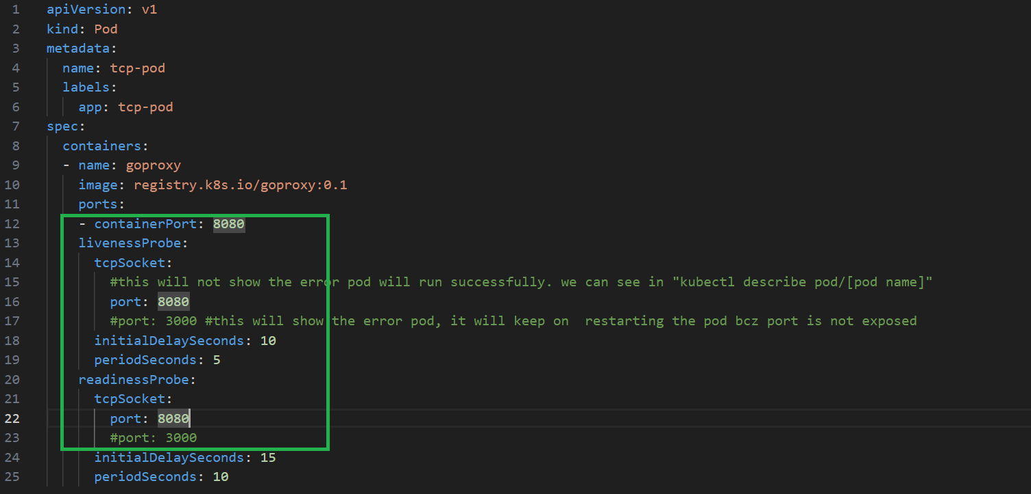

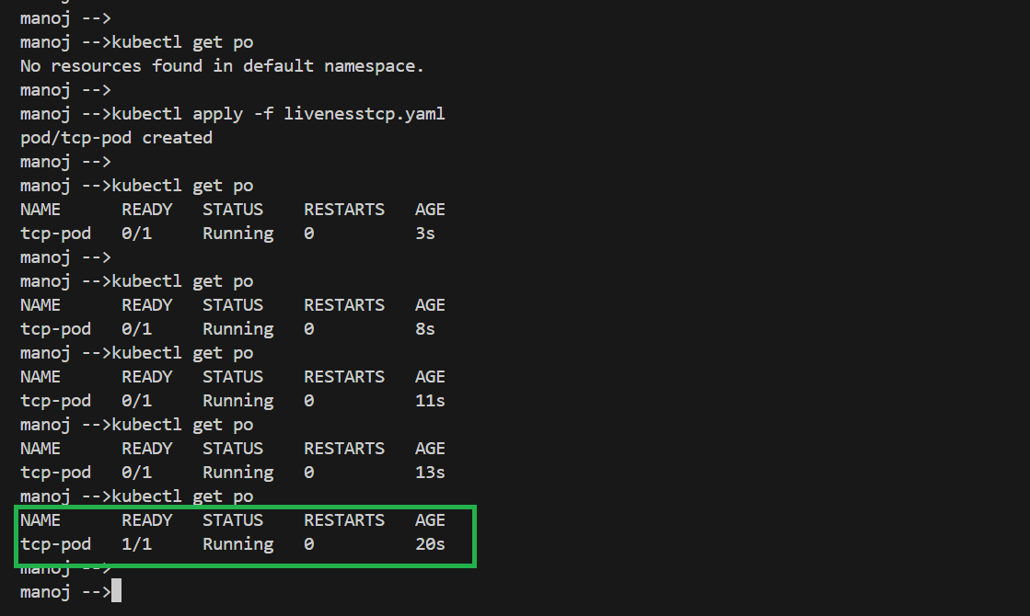

We can see both probes are passed successfully

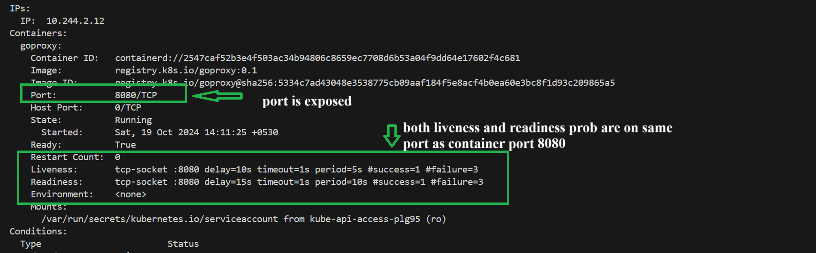

**Now I’m exposing only readiness probe port but not the liveness probe port**

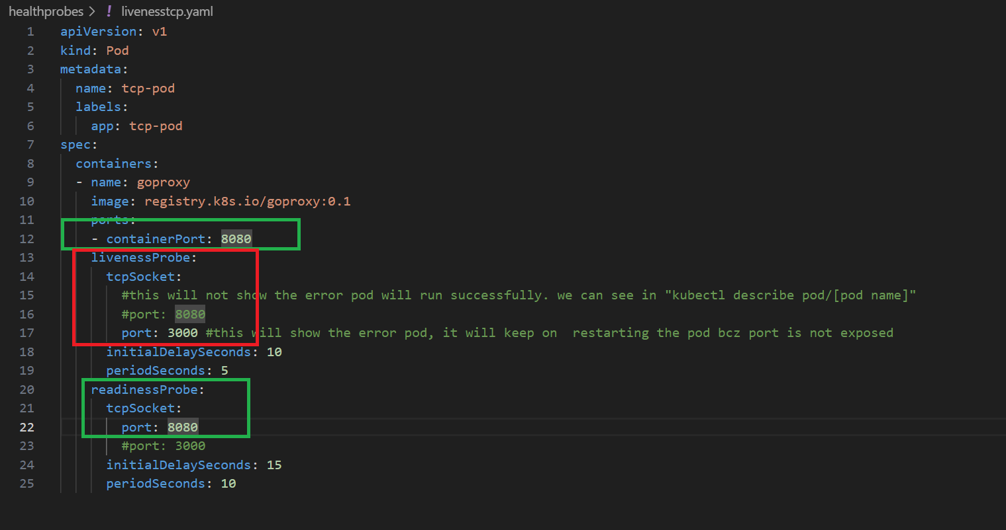

Because liveness probe failed application is restarting again and again.

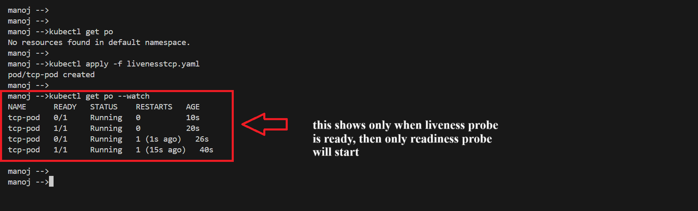

We can see container port is exposed to 8080 but liveness probe is exposed on 3000

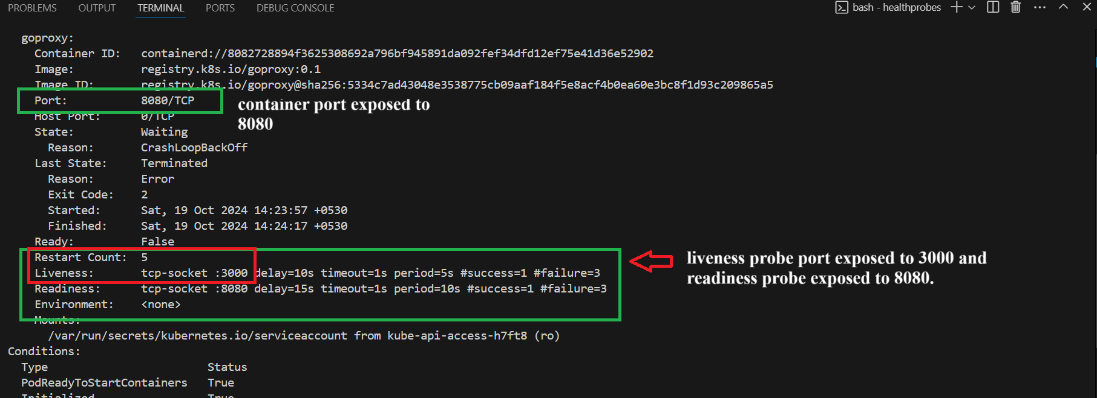

We can see the ERROR

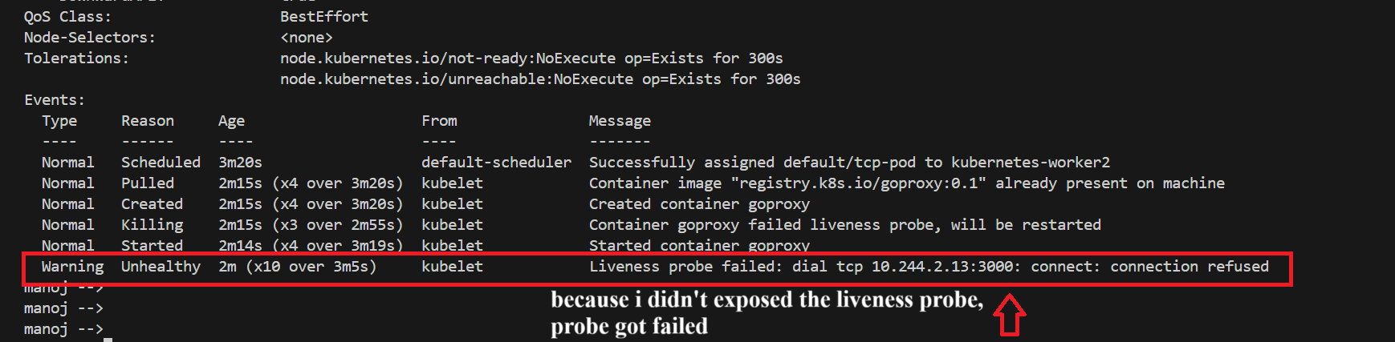

**Now I exposed liveness probe but not the readiness probe**

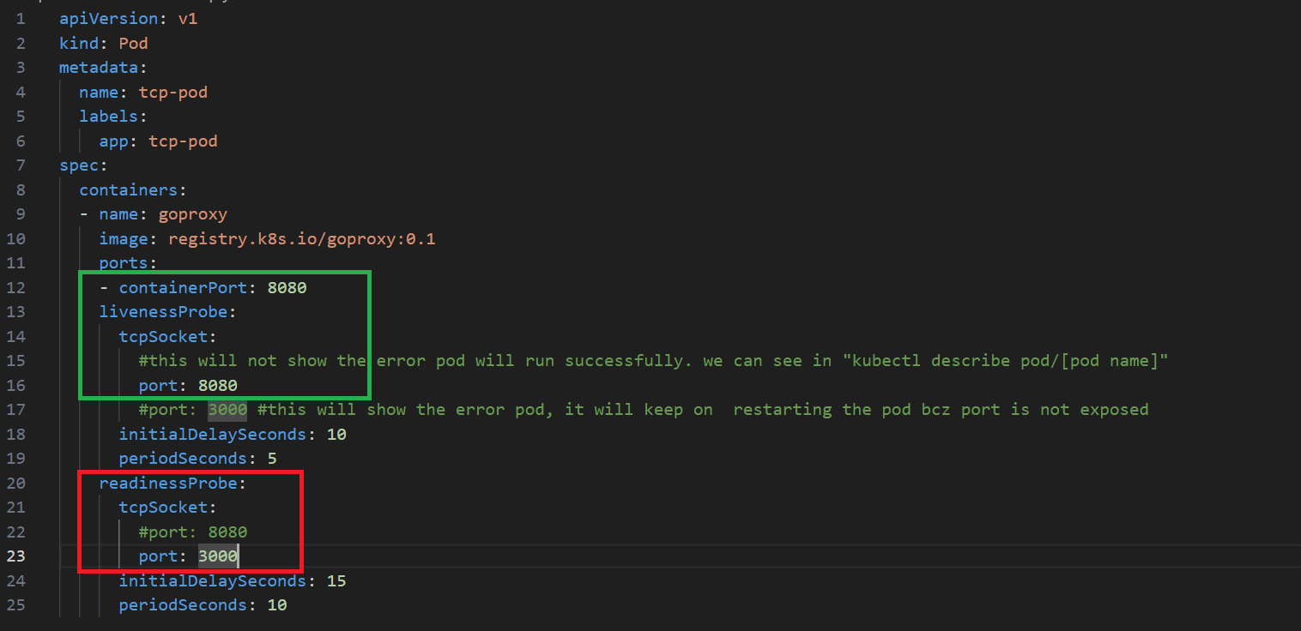

We can see container running successfully but “not READY”

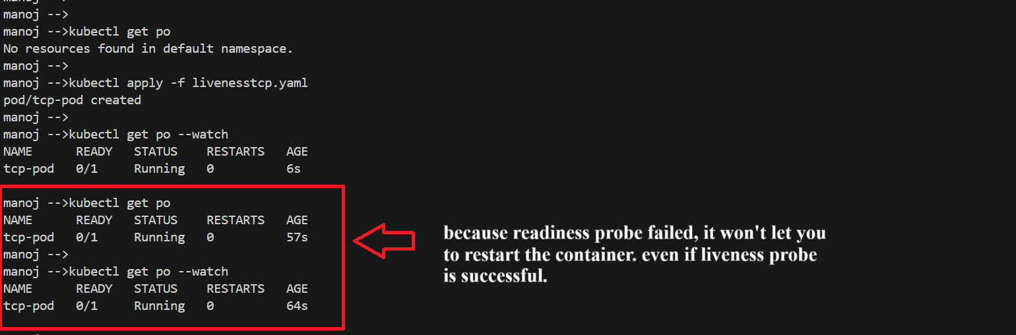

Because readiness probe failed, container was still in “not ready” state.

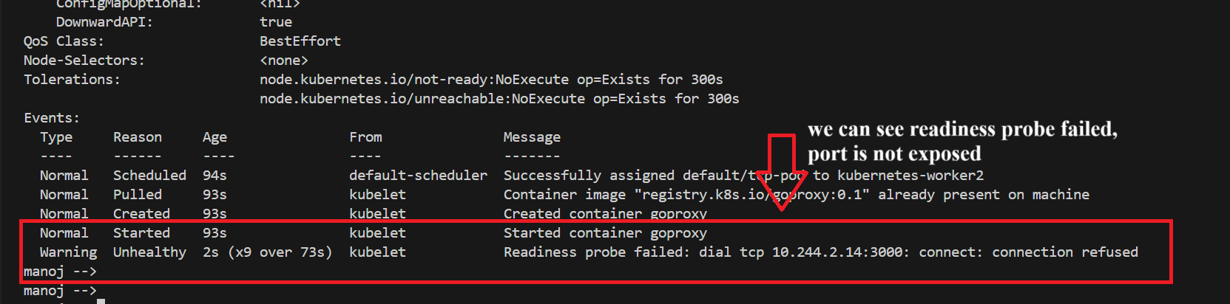

**In-short:**

* **Liveness Probes**: Check if the application is alive.
* **Readiness Probes**: Check if the application is ready to serve traffic.
* **Startup Probes**: Ensure that the application has successfully started before other probes run.